**Database Design**

# **Introduction**

1.1 Purpose of the document

The purpose of a document in the context of database design for a cinema ticket system is to outline the overall structure, functionality, and specifications of the database. This document serves as a blueprint for designing and implementing the database system, providing a clear understanding of its purpose and how it will meet the requirements of the cinema ticketing system.

1.2 Overview of the database design

The database design for a cinema ticket system encompasses the creation of a well-organized and optimized database that effectively stores and handles data pertaining to movies, theaters, showtimes, tickets, and other pertinent entities. The primary objective of the design is to cater to the specific functionalities and demands of the cinema ticketing system, ensuring a dependable and scalable solution for efficiently managing tasks such as ticket bookings, seat allocation, and associated operations. By establishing an appropriate database structure and implementing efficient data handling mechanisms, the design facilitates seamless and reliable operations within the cinema ticket system.

1. **Database Requirements**

2.1 Description of the data requirements for the system

The data requirements for the cinema ticket system can include the following:

- Movies:

Title: The title or name of the movie.

Description: A brief description or summary of the movie.

Movie: The movie being shown, referenced by the movie's unique identifier.

- Theater Room: The specific theater room where the movie is being shown, referenced by the room's unique identifier.

Showtime Spot: The time slot or period during which the movie is scheduled to be shown (e.g., 10-12, 12-14, etc.).

Tickets: The list of tickets associated with the showtime, referenced by the ticket's unique identifier.

Price Rates: The different price rates or categories for the showtime.

Showtime Date: The date when the showtime is scheduled to take place.

- Tickets:

Movie Showtime: The specific showtime for which the ticket is purchased, referenced by the showtime's unique identifier.

Seat Code: The unique identifier or code for the seat allocated to the ticket.

Row: The row number of the seat.

Column: The column number of the seat.

Price: The price of the ticket.

Status: The status of the ticket (e.g., available, sold, reserved).

- Users:

First Name: The first name of the user.

Last Name: The last name of the user.

Email: The email address of the user.

Password: The password for the user's account.

Avatar: The user's profile picture or avatar.

Cover Image: The cover image for the user's profile.

Joined Date: The date when the user joined the system.

Phone Number: The phone number of the user.

Role: The role or permission level of the user (e.g., admin, staff).

Bio: Additional information or description about the user.

- Drinks:

Name: The name of the drink.

Price: The price of the drink.

Description: A description of the drink.

Image: The image or photo of the drink.

- Foods:

Name: The name of the food item.

Price: The price of the food item.

Description: A description of the food item.

Image: The image or photo of the food item.

- Theater Rooms:

Name: The name or identifier of the theater room.

RowNum: The total number of rows in the theater room.

SeatNumPerRow: The number of seats per row in the theater room.

Image: The image or layout of the theater room.

2.2 List of the entities and attributes required for the database

Here is a list of the entities and their attributes required for the cinema ticket system database:

1. Movie
   * Title (String, required)
   * Description (String)
2. Showtime
   * Movie (Reference to Movie, required)
   * Theater Room (Reference to Theater Room, required)
   * Showtime Spot (String, required)
   * Tickets (Array of Ticket references)
   * Price Rates (Array of Objects)
   * Showtime Date (Date, required)
3. Ticket
   * Movie Showtime (Reference to Showtime, required)
   * Seat Code (String)
   * Row (Number, required)
   * Column (Number, required)
   * Price (Number, required)
   * Status (String, default: 'available')
4. User
   * First Name (String, required)
   * Last Name (String, required)
   * Email (String, required)
   * Password (String, required)
   * Avatar (String)
   * Cover Image (String)
   * Joined Date (Date)
   * Phone Number (String)
   * Role (String, required, default: 'STAFF', enum: ['ADMIN', 'STAFF'])
   * Bio (String)
5. Drink
   * Name (String, required)
   * Price (Number, required)
   * Description (String)
   * Image (String)
6. Food
   * Name (String, required)
   * Price (Number, required)
   * Description (String)
   * Image (String)
7. Theater Room
   * Name (String, required)
   * RowNum (Number, required)
   * SeatNumPerRow (Number, required)
   * Image (String)

2.3 Explanation of the relationships between entities

1. Movie and Showtime:

The "Movie" entity and the "Showtime" entity have a one-to-many relationship.

Each "Movie" can have multiple "Showtimes", but each "Showtime" belongs to only one "Movie".

This relationship is established through the "Movie" reference in the "Showtime" entity.

1. Showtime and Theater Room:

The "Showtime" entity and the "Theater Room" entity have a one-to-one relationship.

Each "Showtime" is associated with a specific "Theater Room" where the movie will be shown.

This relationship is established through the "Theater Room" reference in the "Showtime" entity.

1. Showtime and Ticket:

The "Showtime" entity and the "Ticket" entity have a one-to-many relationship.

Each "Showtime" can have multiple "Tickets", but each "Ticket" belongs to only one "Showtime".

This relationship is established through the "Tickets" array reference in the "Showtime" entity.

1. Ticket and User:

The "Ticket" entity and the "User" entity have a many-to-one relationship.

Each "Ticket" is associated with a specific "User" who purchased it.

This relationship is established through the "User" reference in the "Ticket" entity.

1. Order and Food/Drink:

The "Order" entity has a many-to-many relationship with the "Food" and "Drink" entities.

Each "Order" can include multiple "Food" items and multiple "Drink" items, and each "Food" and "Drink" item can be part of multiple "Orders".

This relationship is established through the "food" and "drink" references in the "Order" entity.

**3. Database Design**

3.1 Detailed description of the database design

1.Movie:

Attributes:

title: The title of the movie.

description: The description or summary of the movie.

Relationships:

Has a one-to-many relationship with Showtime.

Has a one-to-many relationship with Ticket.

2. Movie Showtime:

Attributes:

showtimeSpot: The time slot of the movie showtime (e.g., '10-12', '12-14', etc.).

showtimeDate: The date of the movie showtime.

Relationships:

Belongs to one Movie.

Belongs to one Theater Room.

Has a one-to-many relationship with Ticket.

3.Theater Room:

Attributes:

name: The name or identifier of the theater room.

rowNum: The number of rows in the theater room.

seatNumPerRow: The number of seats per row in the theater room.

Relationships:

Has a one-to-one relationship with Showtime.

4.Ticket:

Attributes:

seatCode: The code or identifier of the seat.

row: The row number of the seat.

column: The column number of the seat.

price: The price of the ticket.

status: The status of the ticket (e.g., 'available', 'reserved', etc.).

Relationships:

Belongs to one MovieShowtime.

Belongs to one User.

Has a many-to-many relationship with Order.

5.User:

Attributes:

firstname: The first name of the user.

lastname: The last name of the user.

email: The email address of the user.

password: The password of the user.

avatar: The avatar image of the user.

coverImage: The cover image of the user.

joinedDate: The date when the user joined.

phoneNumber: The phone number of the user.

role: The role of the user (e.g., 'ADMIN', 'STAFF', etc.).

bio: The biography or description of the user.

Relationships:

Has a one-to-many relationship with Ticket.

6.Order:

Attributes:

totalPrice: The total price of the order.

Relationships:

Has a many-to-many relationship with Ticket.

Has a many-to-many relationship with Food and Drink.

7.Food:

Attributes:

name: The name of the food item.

price: The price of the food item.

description: The description of the food item.

image: The image of the food item.

Relationships:

Has a many-to-many relationship with Order.

8.Drink:

Attributes:

name: The name of the drink item.

price: The price of the drink item.

description: The description of the drink item.

image: The image of the drink item.

Relationships:

Has a many-to-many relationship with Order.

3.2 Discussion of any design choices and trade-offs

1. Entity-Attribute-Value (EAV) for Food and Drink:

The Food and Drink entities have a dynamic set of attributes such as name, price, description, and image. To handle this variability, the EAV model is used, where each attribute is stored as a key-value pair in a separate table.

Trade-off: While the EAV model provides flexibility for adding new attributes without altering the database schema, it can lead to complex queries and slower performance when retrieving or updating attribute values.

1. Many-to-Many Relationships:

The relationships between entities like Order-Ticket, Order-Food, Order-Drink are modeled as many-to-many relationships using intermediate join tables.

Trade-off: Many-to-many relationships offer flexibility and allow multiple entities to be associated. However, they can introduce complexity in query construction and potentially impact performance when dealing with large data sets.

1. Denormalization:

In some cases, certain attributes are duplicated across multiple entities to improve performance by reducing the need for joins or aggregations.

Trade-off: Denormalization can improve performance for read operations but may lead to data redundancy and the need for additional effort to ensure data consistency during updates.

1. Use of ObjectIDs and References:

The use of ObjectIDs and references in relationships (e.g., MovieShowtime referencing Movie, Ticket referencing MovieShowtime) helps maintain data integrity and enforce referential integrity constraints.

Trade-off: ObjectIDs and references can add complexity to queries that involve traversing relationships, and they may require additional overhead for maintaining referential integrity.

1. Data Validation and Constraints:

Required fields, data types, and constraints are defined to ensure data integrity and enforce business rules.

Trade-off: Strict data validation and constraints can add complexity to data entry and may require careful consideration during data updates or migrations.

Overall, the design choices in the cinema ticket system database aim to balance flexibility, performance, and data integrity. Each choice involves trade-offs, and the specific needs of the application, data volume, and expected usage patterns should be considered when evaluating these trade-offs.

1. **Database Schema**

4.1 Visual representation of the database schema (e.g. ER diagram)

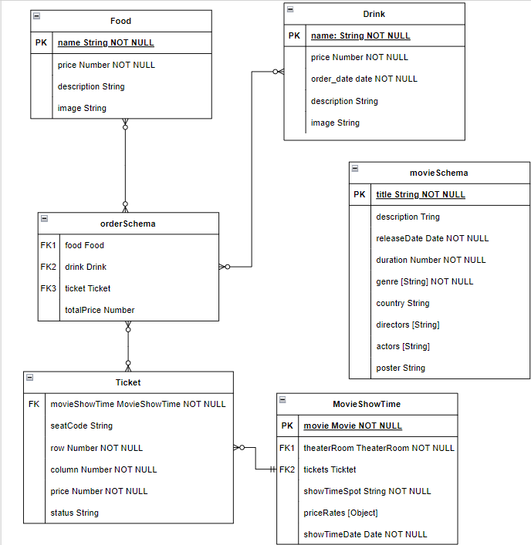

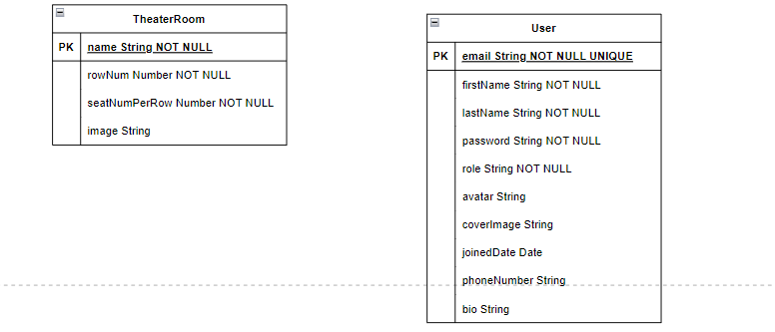

4.2 Explanation of the relationships between tables and entities

1.Movie:

Relationships:

Has a one-to-many

relationship with Showtime.

Has a one-to-many

relationship with Ticket.

2. Movie Showtime:

Relationships:

Belongs to one Movie.

Belongs to one Theater Room.

Has a one-to-many

relationship with Ticket.

3.Theater Room:

Relationships:

Has a one-to-one

relationship with Showtime.

4.Ticket:

Relationships:

Belongs to one MovieShowtime.

Belongs to one User.

Has a many-to-many

relationship with Order.

5.User:

Relationships:

Has a one-to-many

relationship with Ticket.

6.Order:

Relationships:

Has a many-to-many

relationship with Ticket.

Has a many-to-many

relationship with Food and Drink.

7.Food:

Relationships:

Has a many-to-many

relationship with Order.

8.Drink:

Relationships:

Has a many-to-many

relationship with Order.

**5.Database Implementation**

5.1 Description of the database implementation process

-Database Design

-Entity-Relationship Diagram (ER Diagram)

-Database Creation

-Schema Definition

-Data Migration

-Indexing and Optimization

-Testing and Quality Assurance

-Maintenance and Monitoring

5.2 Discussion of any challenges or issues encountered during implementation

- Data Modeling: Designing an efficient and scalable database schema for the cinema ticket system can be challenging. It involves accurately representing the relationships between entities such as movies, theaters, showtimes, tickets, and customers. Balancing the need for data integrity, performance, and flexibility can be complex.

- Complex Business Logic: Cinema ticket systems often involve intricate business rules and logic, such as seat availability, pricing, discounts, and ticket reservations. Implementing and managing these complex business rules within the database can be challenging, requiring careful consideration and testing.

- Performance Optimization: As the cinema ticket system handles a large volume of data and customer transactions, optimizing database performance is crucial. Ensuring fast and efficient retrieval of movie showtimes, seat availability, and ticket bookings requires well-designed indexes, query optimization, and efficient database operations.

- Concurrency and Transaction Management: Managing concurrent user access and ensuring data consistency during ticket bookings can be challenging. Handling simultaneous requests for the same seat or showtime requires implementing proper transaction management and concurrency control techniques.

- Integration with External Systems: Integrating the cinema ticket system with external systems, such as payment gateways, customer relationship management (CRM) systems, or third-party APIs, can pose challenges. Ensuring smooth data exchange and synchronization between the cinema ticket system and external systems requires careful integration planning and implementation.

- Security and Privacy: Protecting customer data, including personal and financial information, is paramount. Implementing robust security measures, such as data encryption, secure authentication, and access controls, can be challenging but essential to ensure the confidentiality and integrity of customer data.

- User Experience: Designing an intuitive and user-friendly interface for customers to browse movie listings, select seats, and make bookings is crucial for a cinema ticket system. Balancing the need for a rich user experience with the complexity of backend operations and data management can be a challenge.

- Scalability and Availability: The cinema ticket system needs to handle high volumes of concurrent user traffic, especially during peak movie times or ticket releases. Designing the system to scale horizontally or vertically and ensuring high availability through redundancy and failover mechanisms can be challenging but necessary for uninterrupted ticket booking services.

1. **Data Migration**

6.1 Description of the data migration process

Planning: Define the scope of the data migration project, including the types of data to be migrated (e.g., customer information, movie details, showtimes, ticket bookings). Identify the data sources and determine the migration approach (e.g., direct transfer, data integration, data conversion). Create a migration plan that outlines the tasks, timelines, and resources required for successful data migration.

Data Assessment: Evaluate the quality and completeness of the existing data. Identify any data inconsistencies, duplicate records, or data format issues. Clean and preprocess the data to ensure accuracy and integrity before migrating it to the new system.

Data Mapping and Transformation: Map the data fields from the source system to the corresponding fields in the target system. Define the rules and transformations required to convert and format the data appropriately. This may involve data normalization, data type conversions, and data enrichment to align with the data model of the new ticketing system.

Testing and Validation: Perform thorough testing and validation of the data migration process. This includes running test migrations on sample datasets to verify data accuracy and completeness in the target system. Validate the migrated data against the source data to ensure consistency.

Data Extraction and Loading: Extract the data from the source systems or sources using suitable extraction methods. Transform and load the data into the new ticketing system, ensuring proper validation and error handling during the loading process. Monitor the data loading to track progress and address any issues promptly.

Data Reconciliation: Compare the migrated data in the target system against the source data to ensure data integrity. Conduct reconciliation checks to identify any discrepancies or missing data. Resolve any issues and perform additional validation to ensure the accuracy of the migrated data.

Post-Migration Activities: After the migration, conduct data cleanup and archiving of the old systems if necessary. Update any relevant documentation, such as data dictionaries or data flow diagrams, to reflect the changes in the new ticketing system. Communicate the successful completion of the data migration process to stakeholders.

6.2 List of strategies for mitigating data migration risks

- Comprehensive Planning: Develop a detailed migration plan that outlines the tasks, timelines, and resources required. Include contingency plans and risk mitigation strategies to address any potential issues

- Data Validation and Testing: Implement robust data validation processes to ensure data accuracy and integrity. Perform thorough testing on sample datasets and conduct data reconciliation to identify and resolve any discrepancies.

- Data Security Measures: Implement strong data security measures during the migration process to protect sensitive customer information. This includes encryption, access controls, and compliance with data protection regulations.

1. **Data Security**

7.1 Description of the data security measures in place

- Encryption: Encrypt sensitive data to protect it from unauthorized access.

- Access Control: Implement strict access controls to ensure - only authorized personnel can access sensitive data.

- Secure Authentication: Use strong authentication methods like multi-factor authentication to verify user identities.

- Data Masking: Mask or obfuscate sensitive data in non-production environments or when shared with third parties.

- Data Loss Prevention (DLP): Implement measures to detect and prevent data loss or unauthorized data transfers.

7.2 Explanation of any data encryption or access controls

Data security measures in a cinema ticket system include data encryption and access controls. Data encryption transforms sensitive data into an unreadable format, protecting it from unauthorized access. Access controls regulate data access based on user roles and permissions, ensuring only authorized individuals can view and modify the data. These measures enhance data protection, prevent unauthorized use, and ensure compliance with security standards.

1. **Conclusion**

The database design document for the cinema ticket system provides an overview of the data requirements, entity relationships, and attributes. It outlines the implementation process and addresses challenges like data migration. Strategies for mitigating risks, including testing and incremental migration, are discussed. Data security measures, such as encryption and access controls, are also explained. The document concludes with a visual representation of the database schema. It serves as a comprehensive guide for developing and managing the cinema ticket system's database.